Salvatore Rich

Assignment 4

1. Given:

Mean Arrival rate ($λ$) = 0.3 (customers/min)

Uniformly distributed service time = 2.5 – 4.5 minutes

Solution:

The excel spreadsheet has been used to simulate the queuing model, the interarrival time and service time duration has been modified using the following formula:

*Inter Arrival Time =* -ln (1 – RAND ()) * 1/0.3

*Service Time* = RANDBETWEEN (150,270)/60

After the simulation the following data has been observed:

1. The total number of Customer Served in the simulation was **34**
2. Maximum Waiting Time was: **14.10 mins**
3. Average Waiting Time was: **5.10 mins**
4. Total Delay was determined: **193.95 minutes**

The table shows the compilation of the data:



1. Given:

Arrival rate: 480 vehicles/hr for 30 minutes

120 vehicles/hr thereafter

Departure rate: 12 seconds/vehicle

Solution:

1. Arrival rate in minutes for the first 30 mins = 480/60 = 8 vehicles/minutes

Arrival rate in minutes for the rest = (120/60) = 2 vehicles/minutes

Cumulative Arrival (CA) = 8*x* 0 ≤ *x* ≤ 30

2*(*x* – 30) + 240 *x* ≥ 30

Cumulative Departure (CD) = 5*x* *x* ≥ 0

$2(x-30)+240=5x$ $x=60$

So, the queue will disappear at 60min.

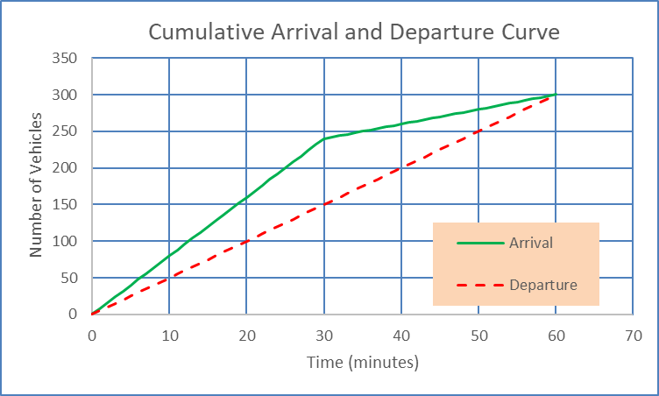

1. Total waiting time:

$T_{total}$ = $Σ(Cumulative Arrival Time)-Σ(Cumulative Departure Time)$

$T_{total}$ = $11850-9150$

$T_{total}$ = $2700 mins$

Average queue length $L_{ave}=2700/60=45$

Average waiting time $T_{ave}={2700}/{300}=9 min$

1. Assigning the first car distance from the signal as 300 feet, the second and the third car distance would be 380 feet and 460 feet respectively.

The initial speed of vehicles: 37.5 mph

Distance between vehicle 1, 2 and 3: 80 feet

Deceleration of vehicle 1: 5mph/sec

Using GM Model 1 characteristics, the table has been formulated in excel using deceleration formula to get the distance from the signal where the collision might occur and the vehicle trajectories has been plotted in excel.

The next graph shows the vehicle trajectories:

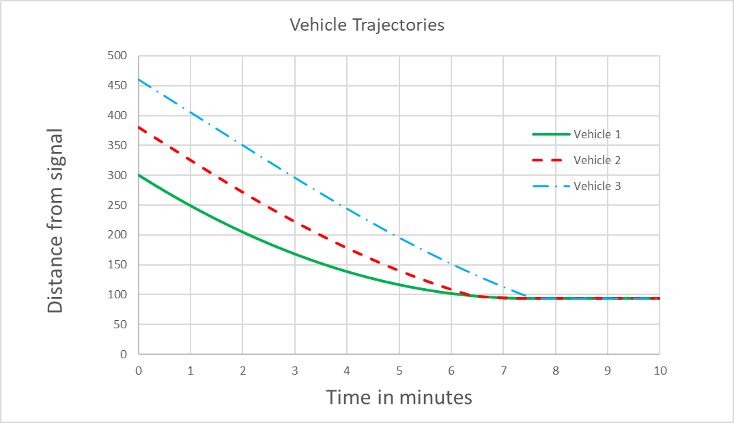

Collision